Short CV Prof.dr.sc. Mladen Radujkovic
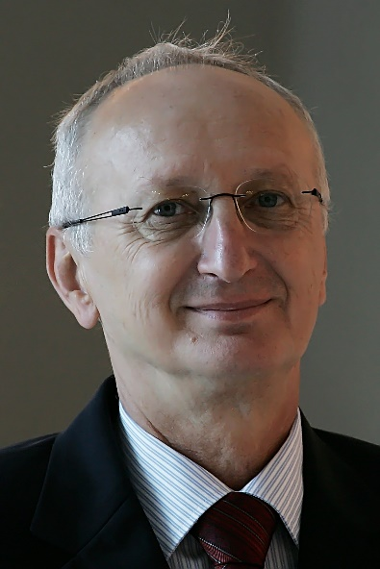
Prof. dr. sc. Mladen Radujković was born in Piran Slovenia. He is Professor of Project Management (PM) and Head of International Doctoral study in PM at Alma Mater Europea European Centre Maribor (AME ECM) in Maribor, Slovenia so as visiting Professor at Huazhong University of Science and Technology (HUST), Wuhan China since 2015. In parallel he is Director of the consulting company Project, Program and Portfolio Expert (PPPE). He is President of the Croatian Association for Project Management (CAPM), one of the founders of regional PM association (SENET), so as Honorary Fellow at International Project Management Association (IPMA). In 2018. he is elected as member of European Academy of Science and Arts (EASA).
For more than 25 years he served as Professor of Project Management and Construction Management at the University of Zagreb, Croatia. During the period 2002-2006. he hold position of Vice dean for research, while from 2006-2010. he was Dean at the Faculty of Civil Engineering. During the last eleven years he had key positions at International Project Management Association (IPMA) headquartered in Switzerland. He used to be IPMA vice-president for education and research during three mandates 2007-2012., President in mandate 2013-2014. and Chair of the IPMA Council of Delegates for 2014-2017. He holds several international certificates in PM, like IPMA senior project manager certificate, First assessor certificate for "IPMA 4LC” for Croatia and Bosnia and Herzegovina, so as USAID / Booz Allen USA ToT certificate I-IV for infrastructure PM.
During his career he worked on various jobs including site engineer, project manager, consultant, and professor. At the same time, he held various leadership positions at companies, associations or universities, such as director, vice dean, dean, vice president, president, chairman.
His academic career includes courses conceptualization and teaching at the undergraduate, graduate and postgraduate university studies, including specialized postgraduate studies titled UNIZG European Projects, UNIZG MBA in Construction, AME PM at European Business Studies, so as AME Doctoral Study in Project Management. In parallel he designed and delivered around 80 seminars or workshops related to the project management topics or construction management.
His research activities include head positions for 16 research projects related to the areas organization or management. He published around 200 papers mostly at the international level and focused to the PM topics, out of which more than 50 were published in different journals. He holds reviewer position at 6 international scientific PM journals. During the last period he was member of the scientific committee for more than 50 international scientific conferences. In parallel, he delivered about 40 key note lectures at global conferences, organized in Great Britain, Hong Kong, Finland, Germany, France, Slovakia, South Africa, Czech Republic, Hungary, Romania, India, Italy, Poland, Brazil, South Korea, Panama, Peru, China, Lithuania, USA, Chile, Italy, Dominican Republic, Italy, Mexico, Portugal, Indonesia and Iran.
His reference list also includes participation, consulting or management position for more then 100 different complex local or regional projects in the south-east Europe owned by Ilbau Austria, Strabag Germany, Booz Allen Hamilton USA, IPMA International, Importanne, ADRIS Group, EPTISA, Ernst Young Consulting, Croatia insurance, USAID, Croatian waters, IGH, University of Zagreb, AME ECM, etc. implemented in sectors of research & development, infrastructures, construction, tourism, water, transport, entrepreneurship, investment or education.

